Installing SQL Express 2019
Prerequisites
You will need to be running Windows 8, 10 or above, or SQL Server 2012 or above.

Download
You can download SQL Express 2019 using this link:
https://go.microsoft.com/fwlink/?linkid=866658

The screens below show the installation of SQL Express 2016, but it has not changed.
Select Custom:
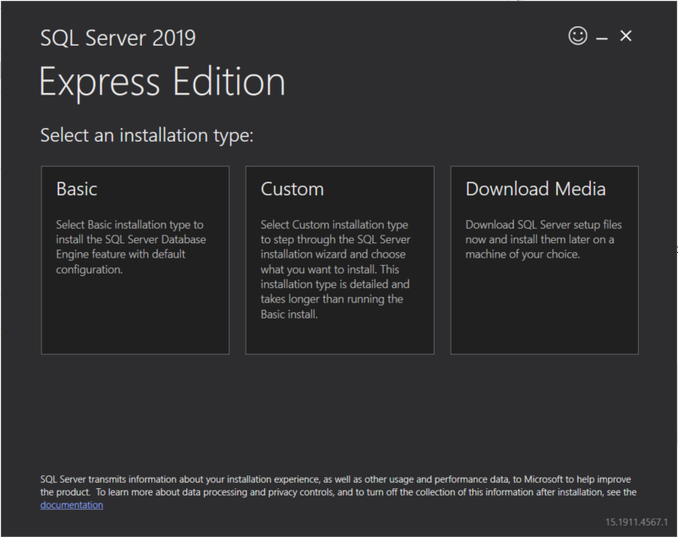

Select the destination for the installation files:
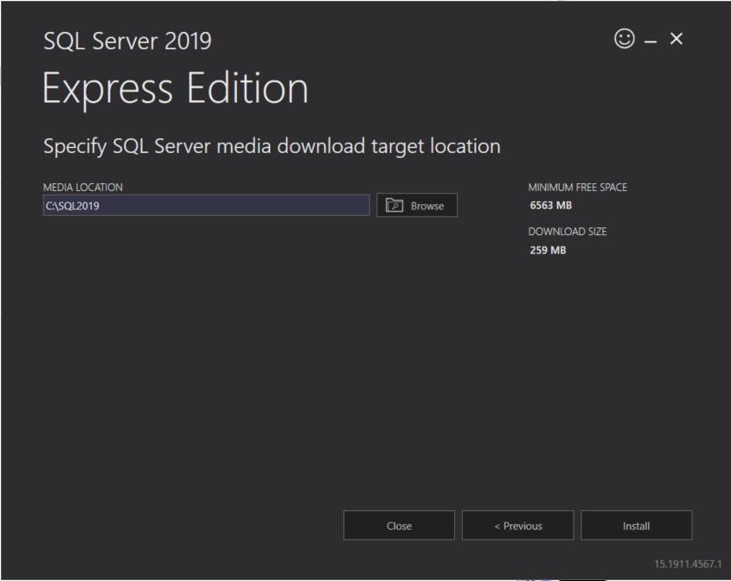
Wait for the download to complete:
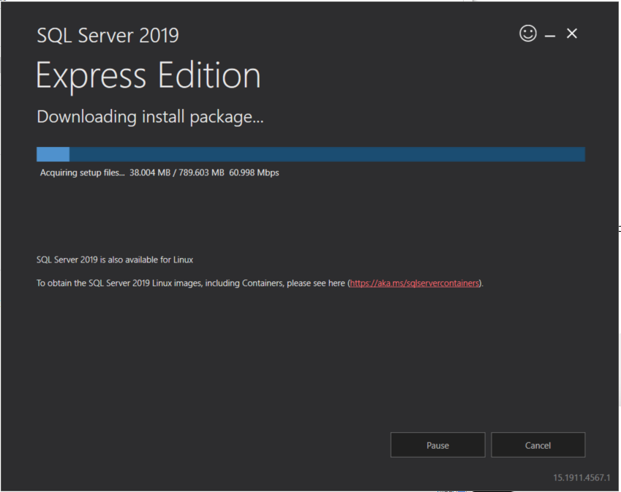

The installation files are then extracted and the SQL Server Installation Centre is started.
Click on SQL Server stand-alone Installation
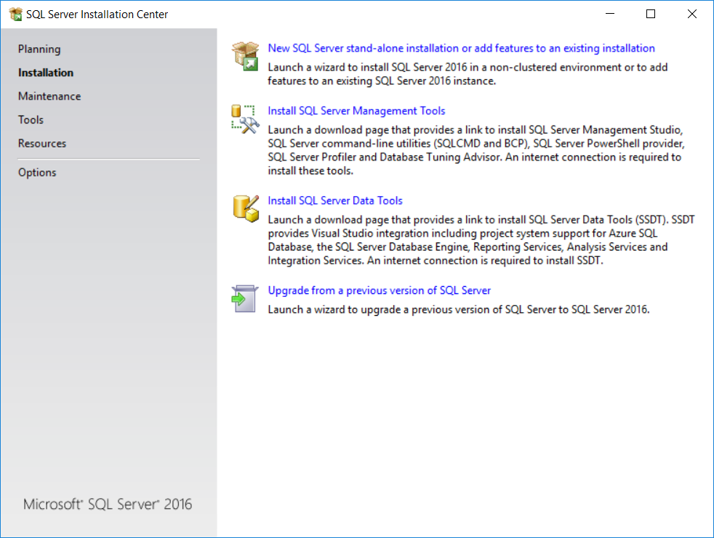
Click on ‘I Accept the license terms’
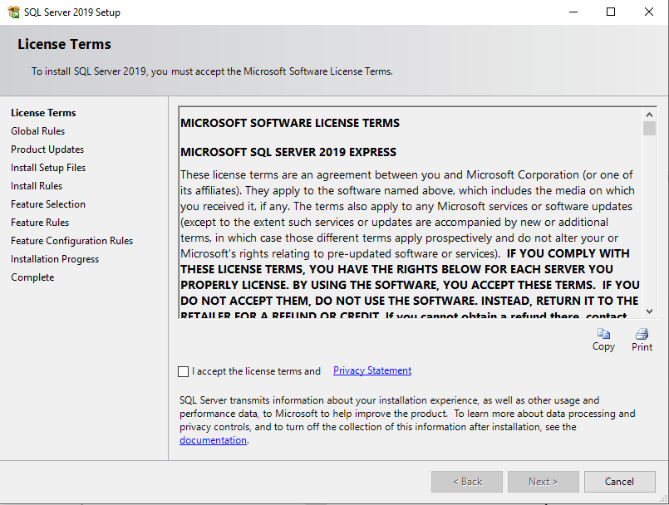
Click Next
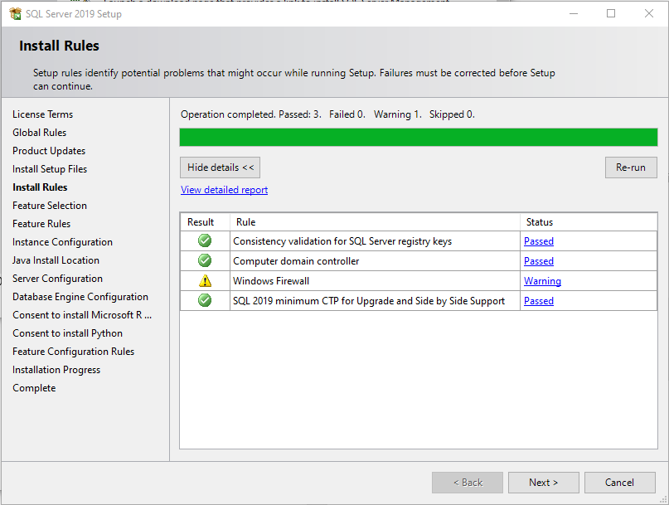
Select the components that you wish to install.
You will probably not require the Machine Learning Services and Language Extensions, the PolyBase Query Service for External Data or the LocalDB
Press Next
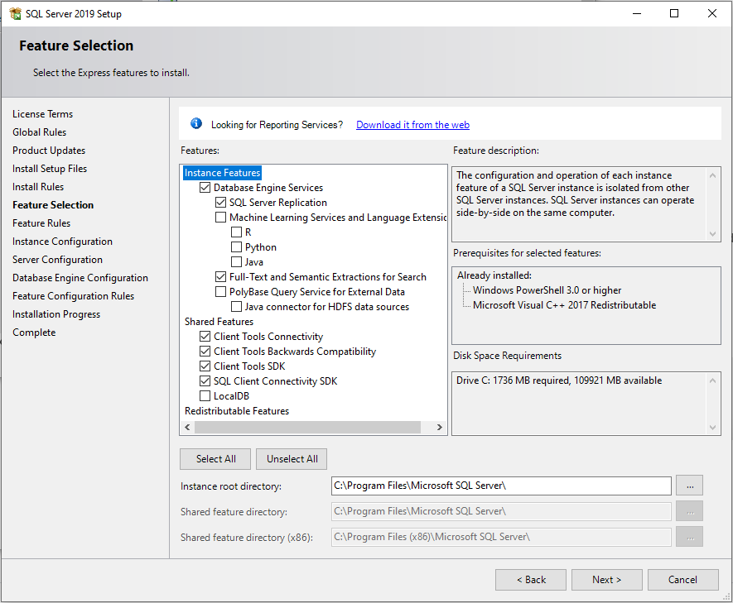

And wait


You can accept the default instance name of SQLExpress or rename it to something else, e.g. SQL2019
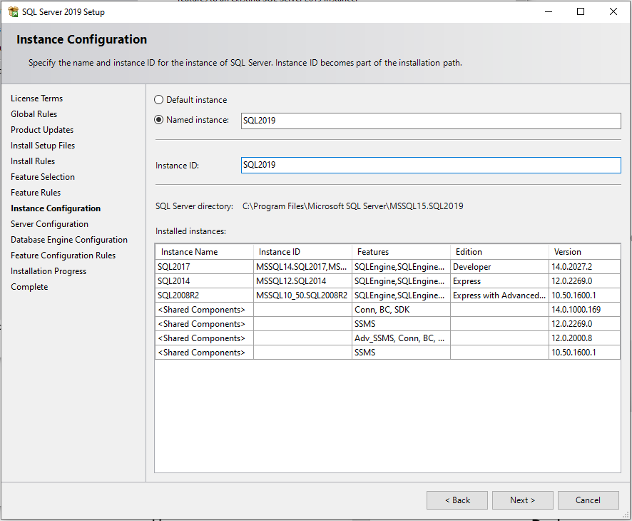

And wait
Press Next
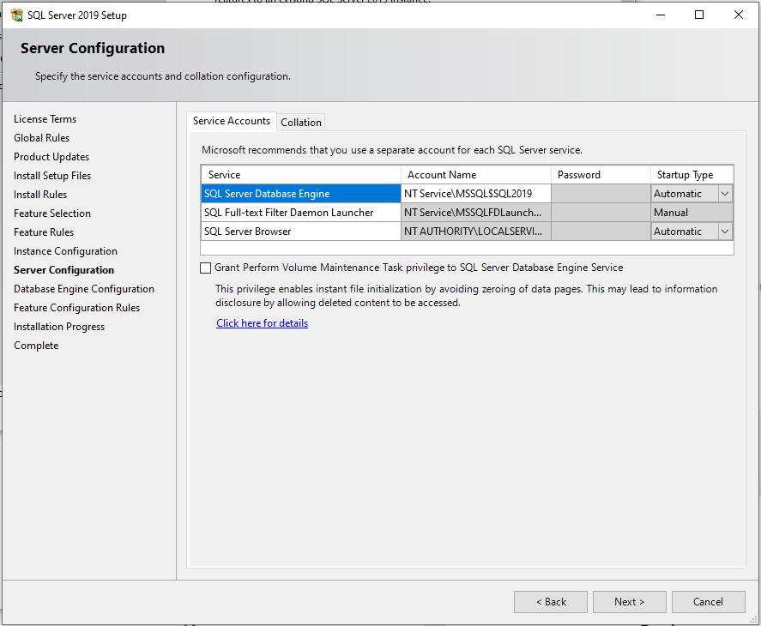
Click on Add Current User. Also add any other users that require access to the database.
Then press next
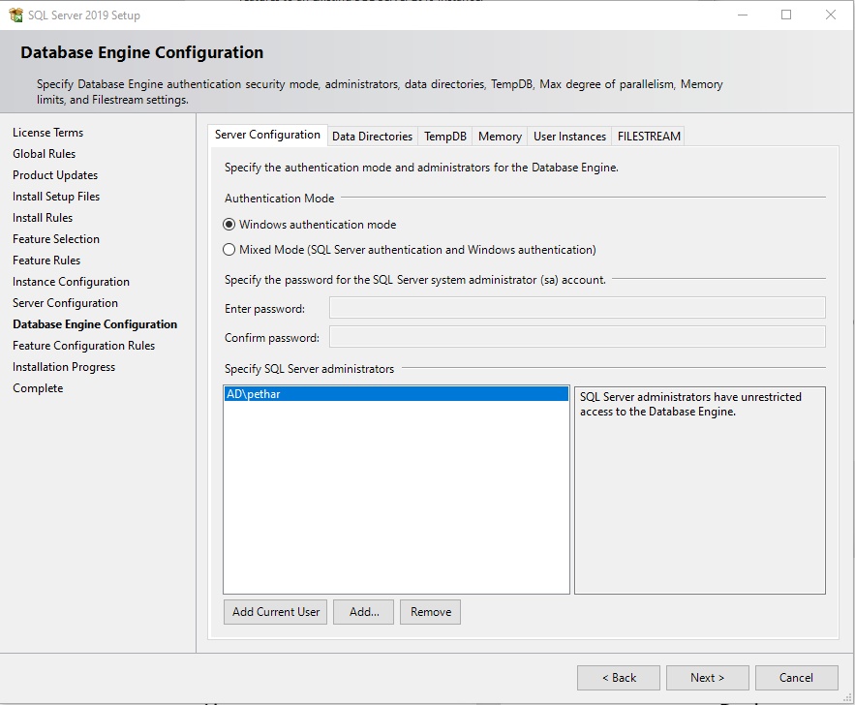
Then wait
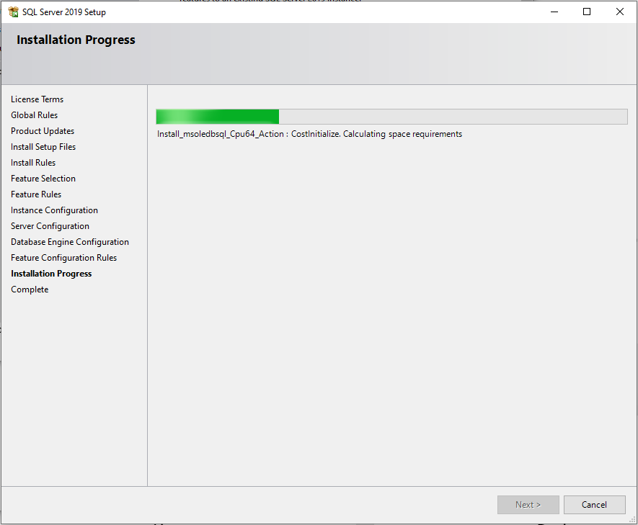

Eventually the software will have been installed
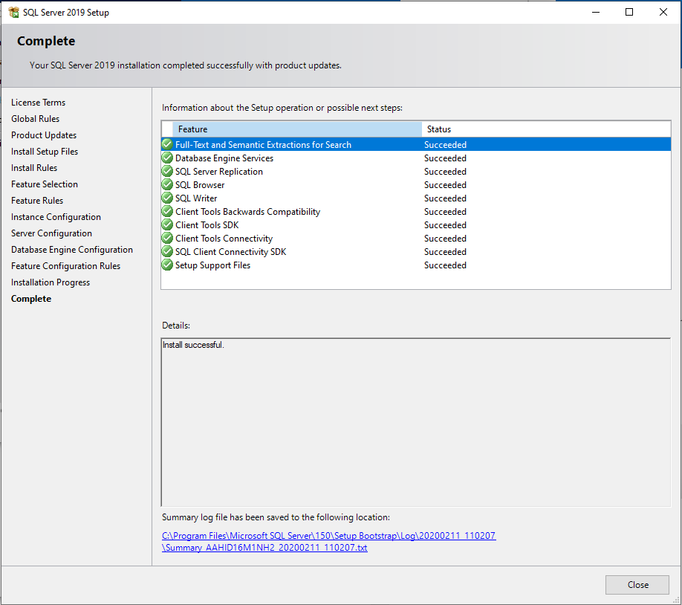
Attach the database
Click on Install SQL Server Management Tools
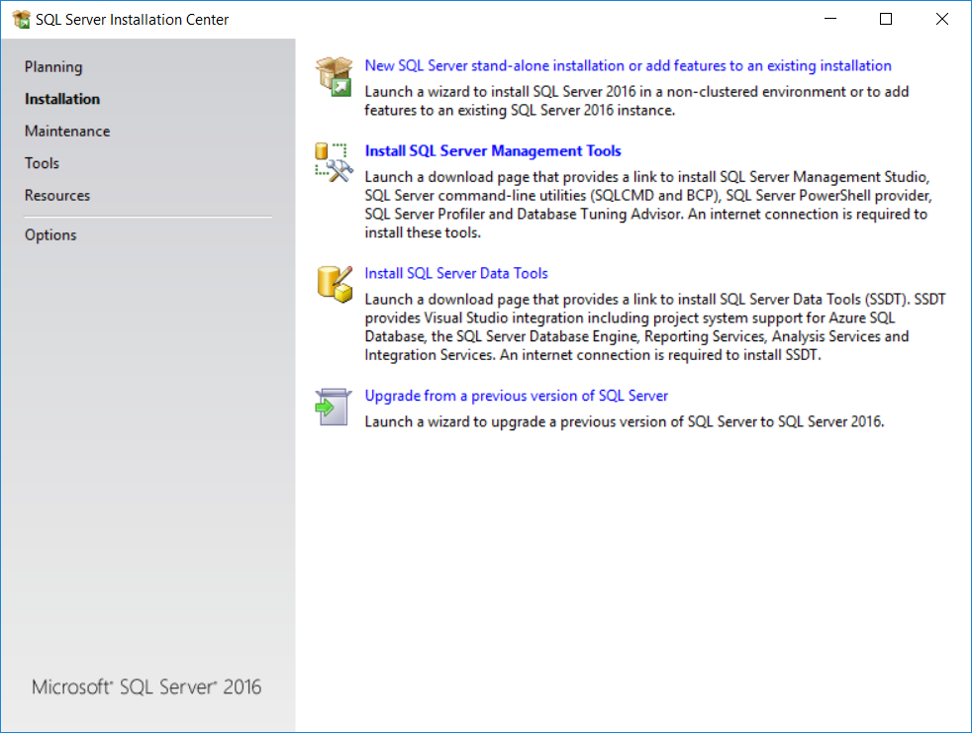
Download the most recent version of the SQL Server Management Studio

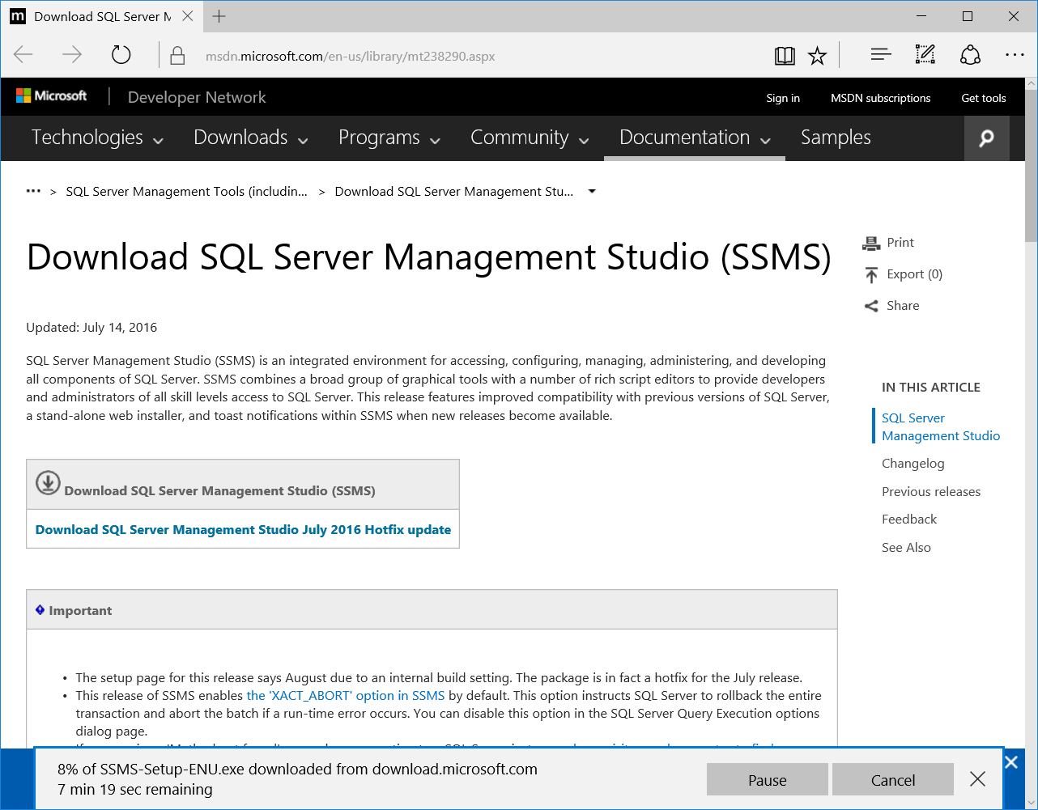

Locate and execute the program SSMS-Setup-ENU
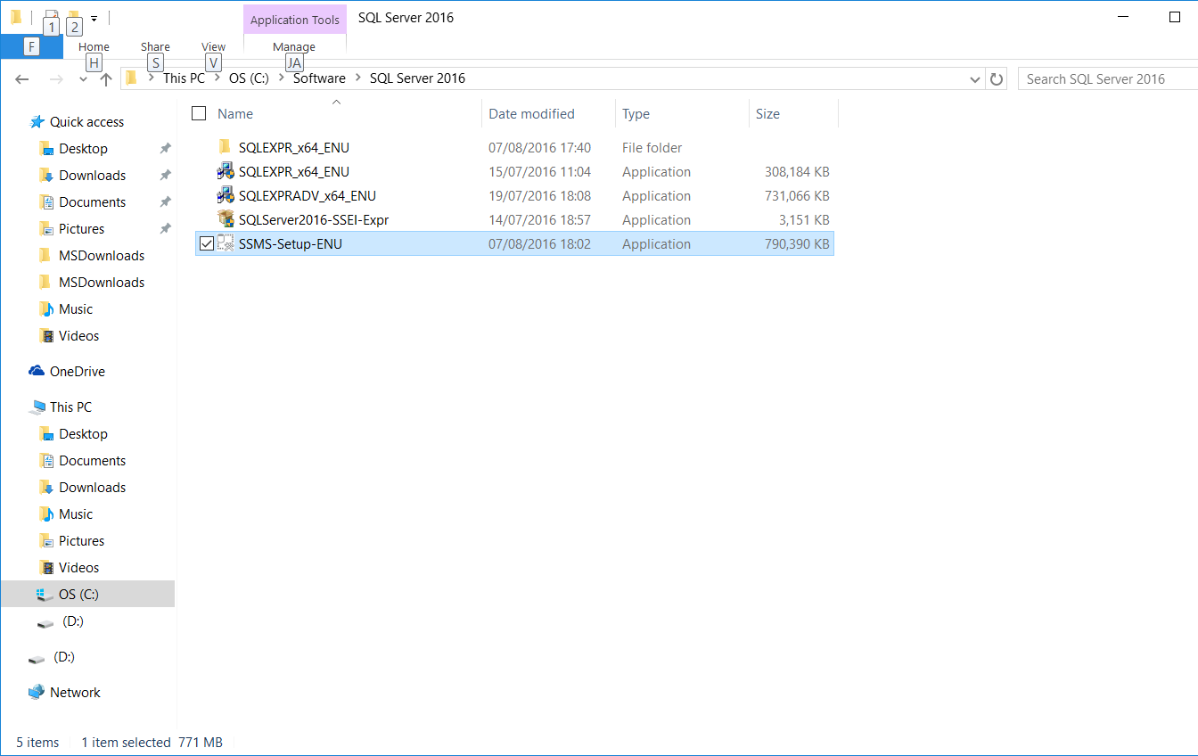

Click Install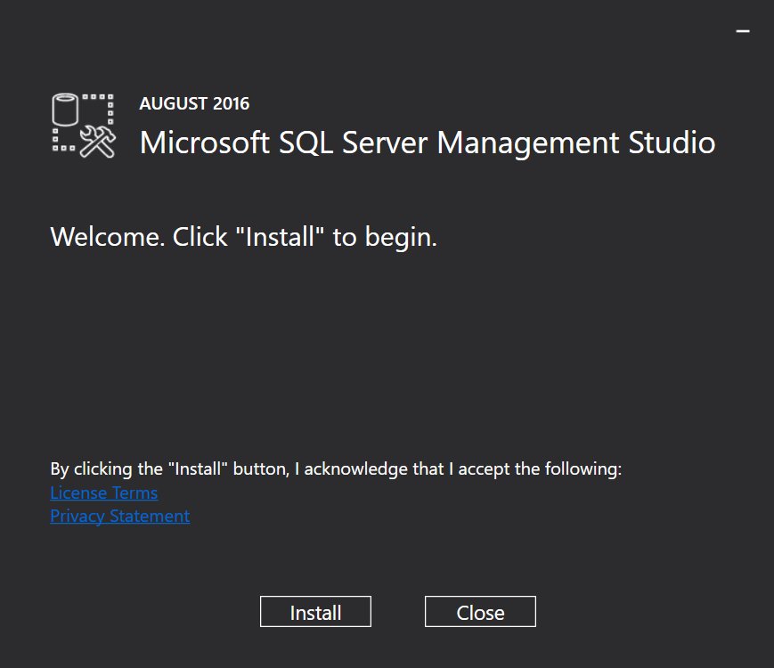
And wait
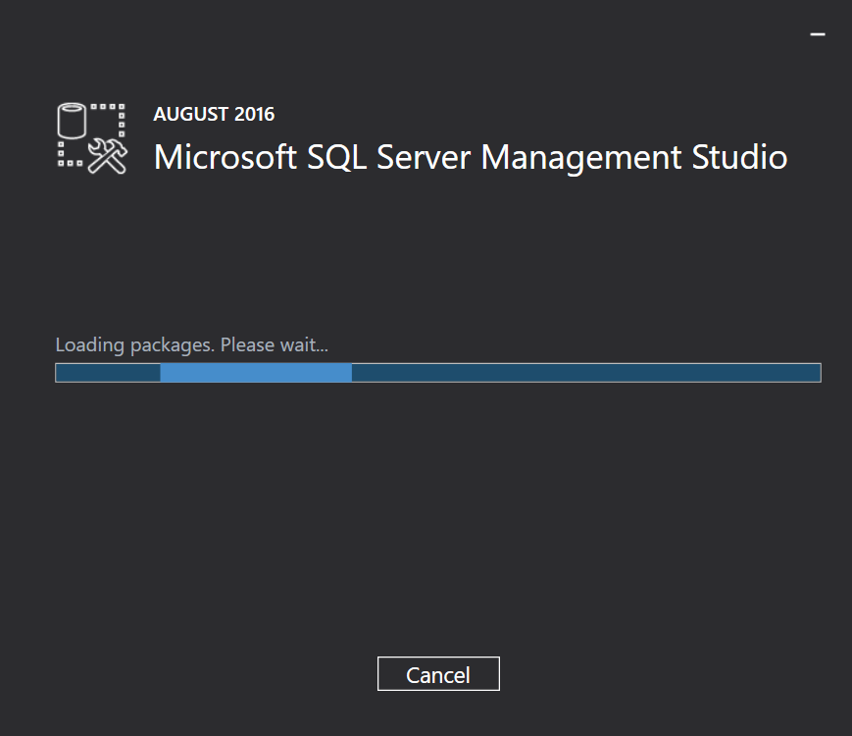

Continue to wait
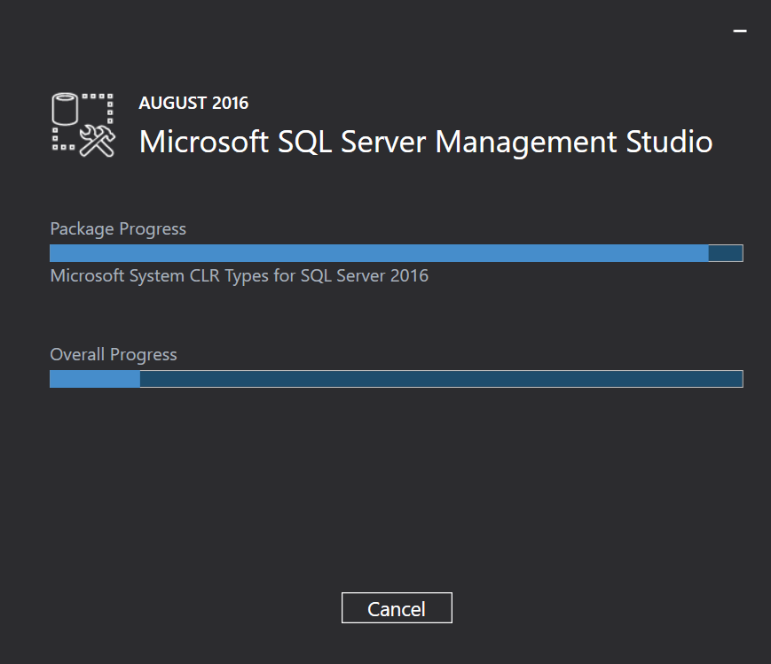
Until the SQL Server Management Studio setup is complete.
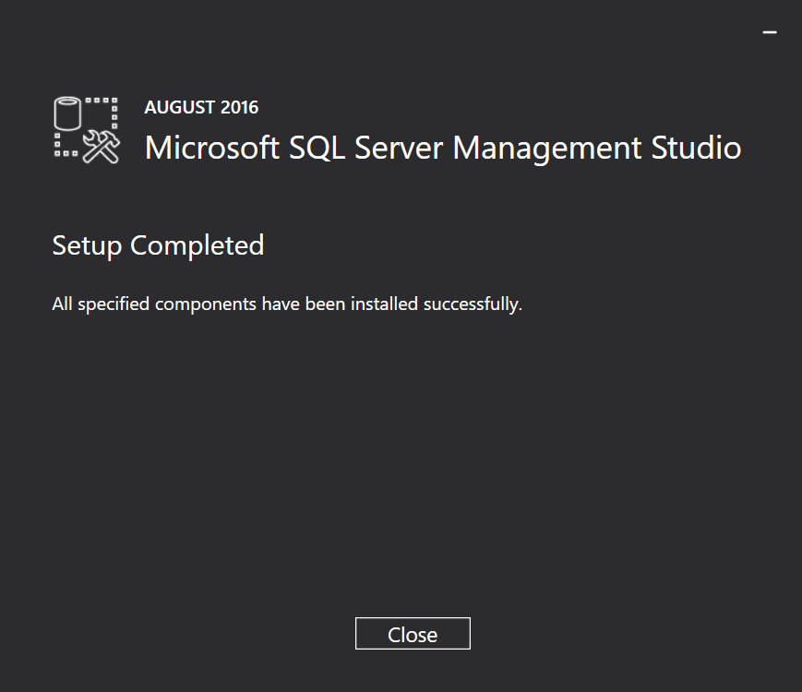
Then run the SQL Server Management Studio
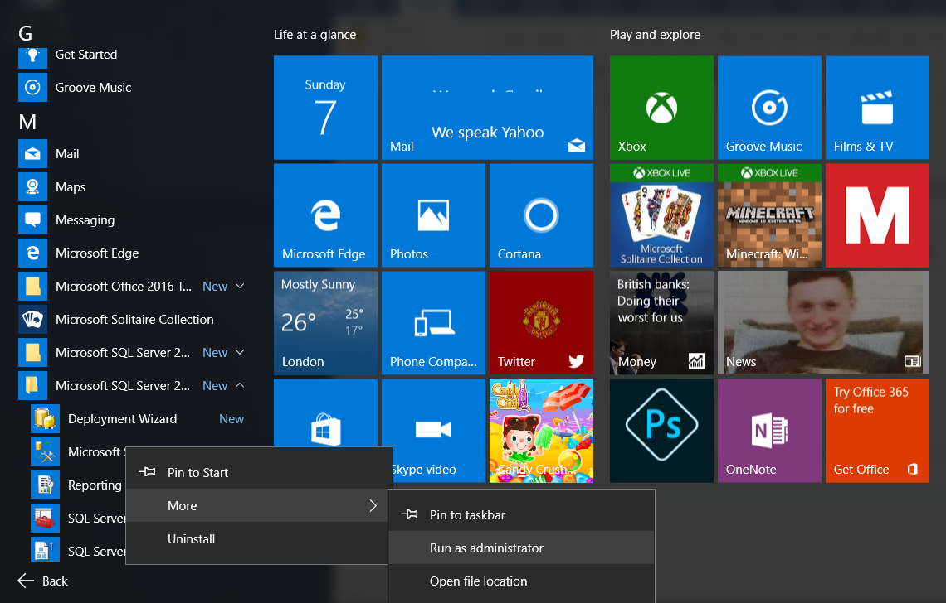

In the Server Name field enter the name of the machine and the instance name that you selected for the database instance
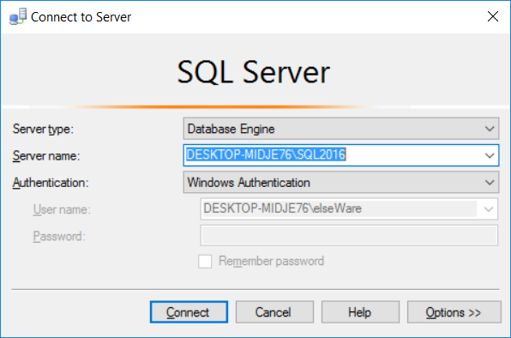

Right click on Databases in the left hand menu, from the subsequent menu select Attach
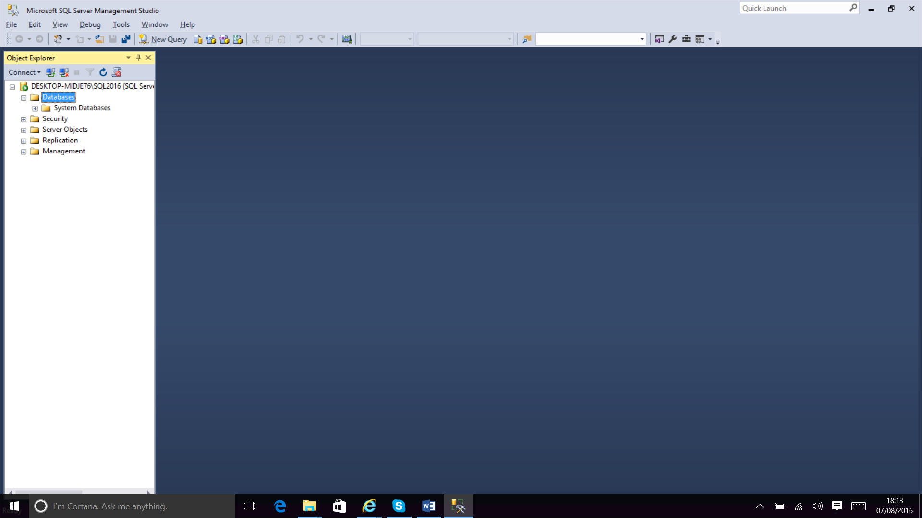
Click Add
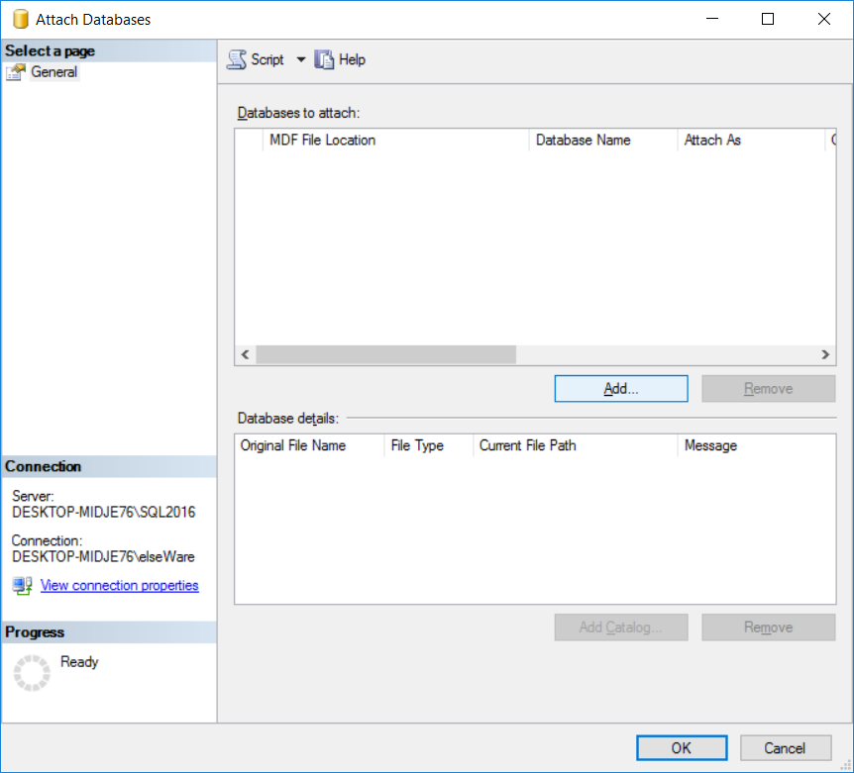
Locate the folder that contains the database ( usually C:\f2b\dB )
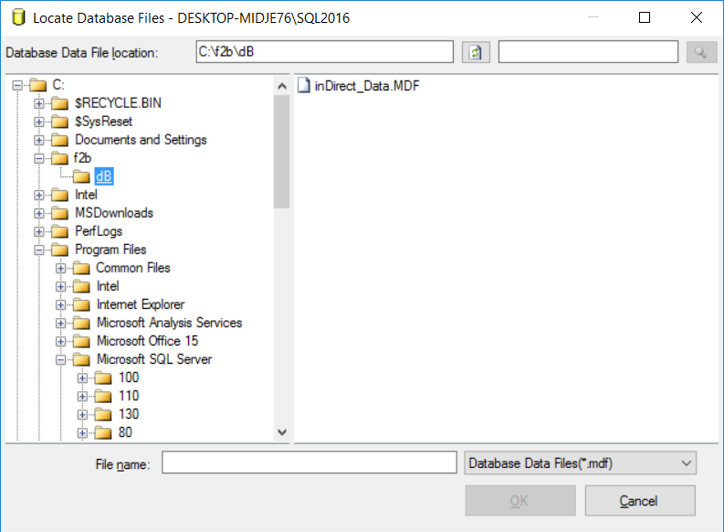
Click on indirect_Data.MDF and then click on OK
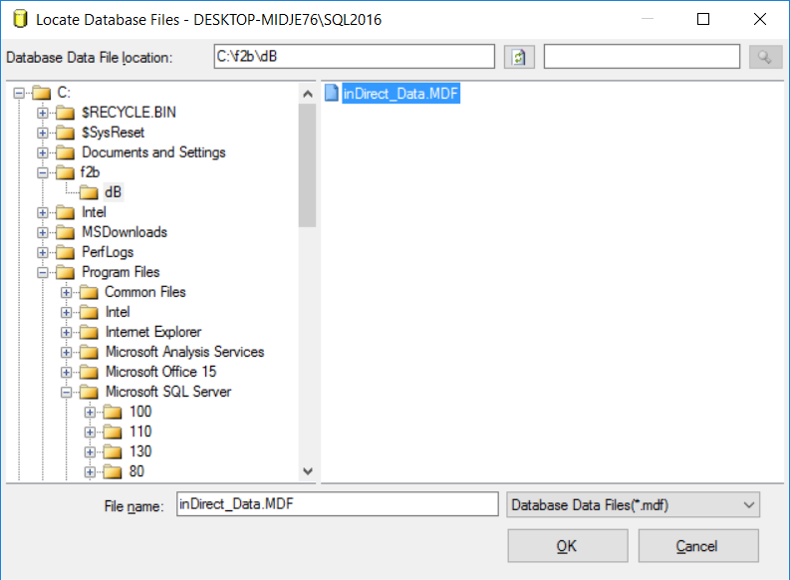

Click on OK
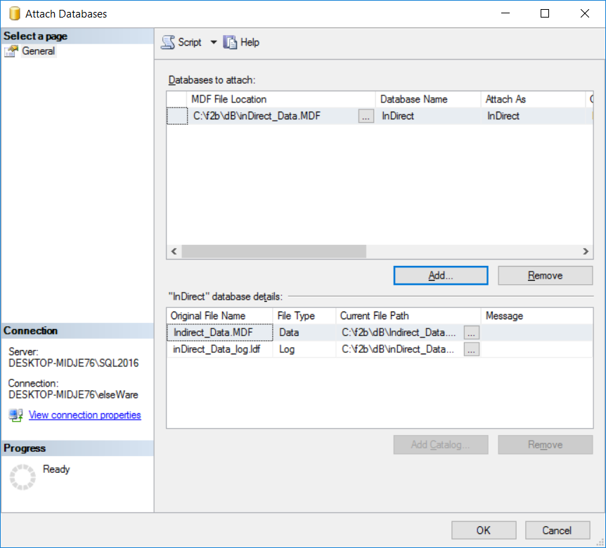
The database should appear in the left hand menu.
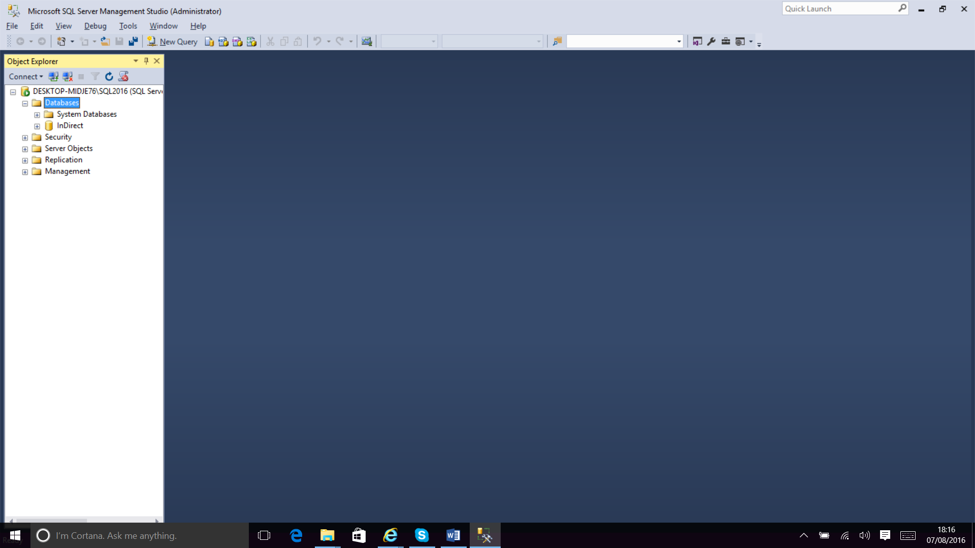

You should edit the file C:\f2b\f2b.INI and ensure that it contains the name of the server and the instance name in the [dB] section as below.
There may be lines that start with an apostrophe around or between the relevant lines. These can be ignored.
[dB]
'ConnectString=Provider=SQLNCLI11; Server=HAMISH\SQL2014; Integrated Security=SSPI; DATABASE=inDirect; SPN='ConnectString=Provider=SQLNCLI11; Integrated Security=SSPI; DATABASE=inDirect; Data Source=tcp:192.168.0.5\SQL2014,1433
Server=GBLUTL-BSVZN72\SQL2016
'Provider=SQLNCLI11
dB=indirect
…

